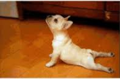**Exercise**

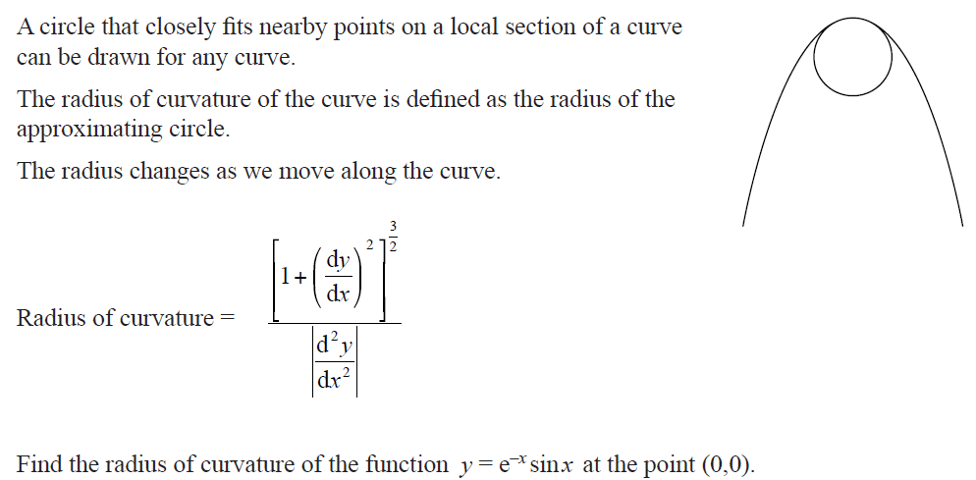

**Applications of Differentiation**

1. Tangents and Normal
2. **Equations of Tangents**

***Method***

1. Differentiate the given function to get the gradient function.
2. Calculate the gradient at the given point. (i.e. )
3. Use the equationor, where (straight line equation) to get the equation of the tangent line.

Example 1;

Write an equation for the tangent to the curve at point (2,4).

Example 2; Write an equation for the tangent to the curve at point (2,0).

Example 3; is tangent to the curve .

1. Find the point where touches the curve.
2. Calculate the value of constant

Example 4;

There are two points on the cubic where the tangent has a gradient equal to . Find the equations of the tangents at these two points.

Example 5

Given the . Find the equation of the tangent at the point .

Example 6:

A curve is given parametrically as Find the equation of the tangent at the point .

Example7:

Find the equation of the tangent to the curve at the point

Example 8;

Find the equation of a tangent to the curve at the point .

1. **Normal**

A normal to a curve is the line that is perpendicular to the tangent to the curve at the point of contact.

**,** where is the gradient of tangent and the gradient of normal.

Example 1

For examples 6 and 8 from above work out the equations of normal.

Example2

The x-coordinate of point P is 1. Point P lies on the curve. Find the equation of a normal at point P.

Example 3

There are two points on the curve where the normal has a gradient equal to 2. Find these two points.

Example 4

A curve has parametric equations:

and

Find the equation of the normal at

**Exercise**

Mr Lal’s pick of the hour

1. Find the equation of the tangent in surd form to the curve (ellipse) defined by, at.
2. The tangent to the curve at point meets the x-axis at point and the y-axis at Find the distance in surd form.
3. Show that the equation of tangent to the curve at point is .
4. Find the equation of a tangent to the curve, and at



1. **Increasing, Decreasing, Stationary Points**

*Stationary Points*

At stationary (turning) point the gradient is zero (0) (i.e. ).

*Types of stationary points*

1. Maximum turning point

At maximum turning point the gradient changes from positive to negative.

1. Minimum turning point

At minimum turning point the gradient changes from negative to positive.

Note:

1. Maximum turning point is often called a ***local maximum.***
2. Minimum turning point is often called a ***local*** ***minimum***.

Increasing and decreasing function

A function will either increase or decrease from a stationary point.

For increasing function gradient is ***positive*** (i.e. )

For decreasing function gradient is ***negative,*** (i.e.).

***Steps***

1. Calculate the of stationary point.
2. Check the sign (+ or -) about the stationary point.



Example

1. For given function, find the place where the function is decreasing and increasing.
2. Find out whether the graph is increasing or decreasing or stationary at point (1, 0).

**Points of inflection (stationary points of inflection)**

A point of inflection is where the graph changes its concavity. Also the sign of gradient remains unchanged.

Concave down concave up

(Concave from below) (Concave from above)

A curve is concave up where

A curve is concave down where

**Determining the Nature of Stationary (Turning) Points**

*Steps:*

1. Differentiate the given function (i.e.).
2. Equate the derivative to 0 (i.e.) and solve for .
3. Find second derivative (i.e.) to determine the nature:

gives a **maximum point**.

gives a **minimum point**.

Where is the -value of the turning point (from step ii).



Note:

To find the **points of inflection,** solve the equation and substitute for:.

Example:

1. Find the coordinates of all the stationary points and state the `nature’ of each one.
2. If .
3. For what value of is not defined?
4. Find .
5. Find the turning points and determine their nature.
6. Find values of for which the function is concave up and concave down.



**Sketching Polynomials**

1. Sketch the graph of

Factorised form of y is .

2. For the curve .

a. find the coordinates of stationary points and identify their nature.

b. find the intercepts

c. sketch the graph of

3. Sketch the graph of





Limit, Continuity and Differentiability

*(Graphical Approach)*

**Sketching derive functions (gradient function)**

Use the concepts of increasing and decreasing functions (i.e. positive and negative gradient).

* For polynomials the turning points will become the -intercepts of the derived functions.
* For hyperbola the asymptote will remain unchanged for the derive function.
* The Absolute value graph will be drawn as a piece-wise function.

**Limits**

The limit of a function exists at all places on a graph.

At the following places on the graph the limit **does not** exist.

1. At the end of a function.
2. When there is a jump.
3. When there is a gap.
4. When there is an asymptote.



**Continuity**

A function is said to be continuous if we can trace the graph without lifting the pen.

At the following places on the graph the function is **not continuous** (discontinuous).

1. At the end of a function.
2. When there is a jump.
3. When there is a gap.
4. When there is a hole.
5. When there is an asymptote.

**Differentiability**

A function is differentiable at all places on the graph.

At the following places on the graph a function is **not** **differentiable** (derivative does not exist).

1. At the end of a function.
2. When there is a jump.
3. When there is a gap.
4. When there is a hole.
5. When there is a corner or edge.
6. When there is an asymptote.



**Note**

A function may be continuous but not differentiable, this occurs at the corner or edge of a function.

**is the gradient function. For a given graph:**

1. at the turning point for parabola and horizontal line for straight line graph.
2. , is a positive gradient.
3. is a negative gradient

**is for concavity. For a given graph:**

1. for point of inflection**.**
2. for maximum point i.e **concave down**.
3. for minimum point i.e **concave up** .

Examples

1

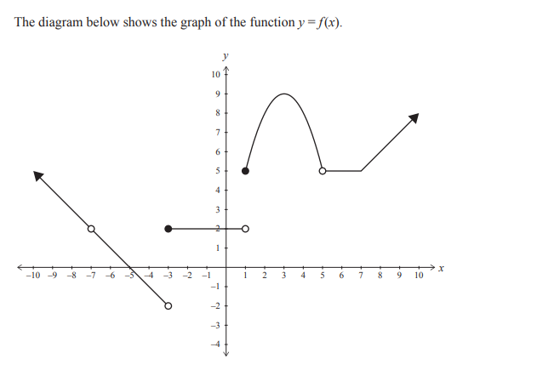

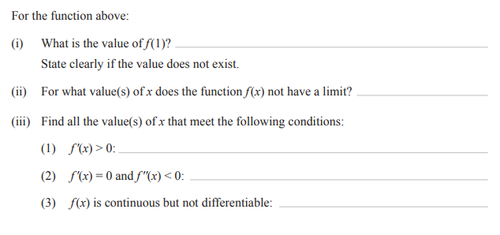

iv) Draw the gradient function

2 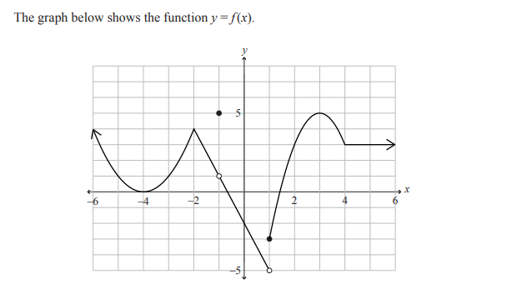

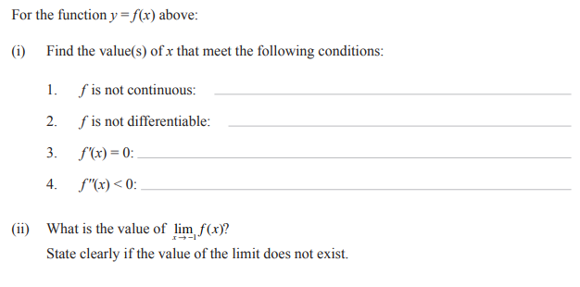

Exercise

1

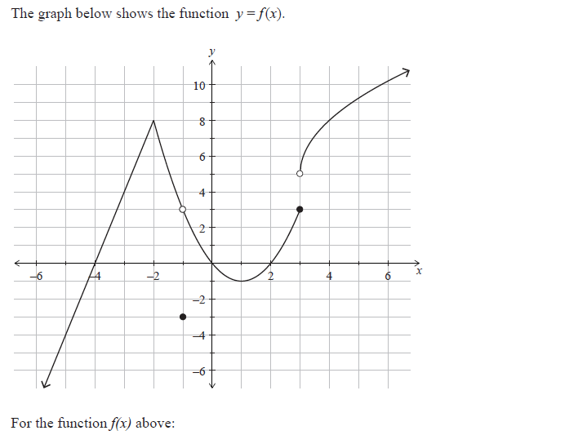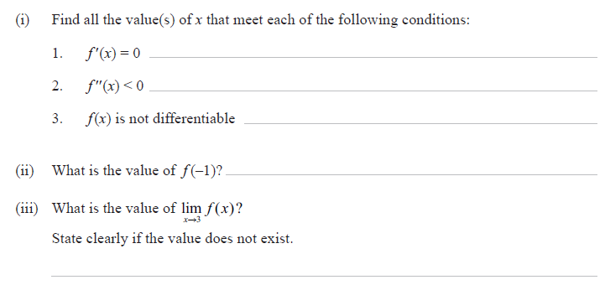

2

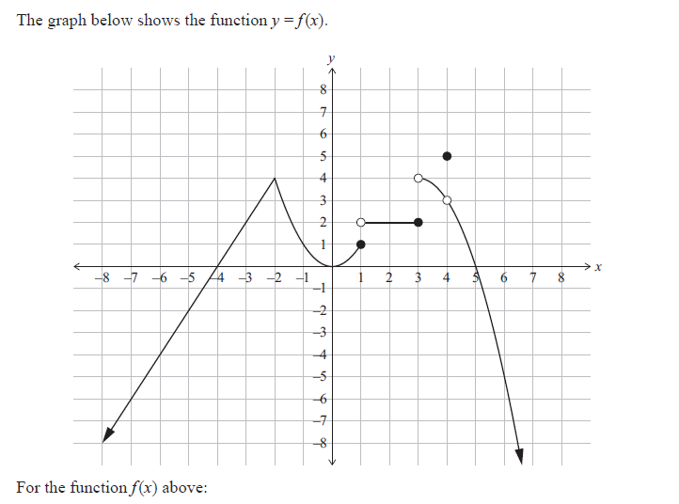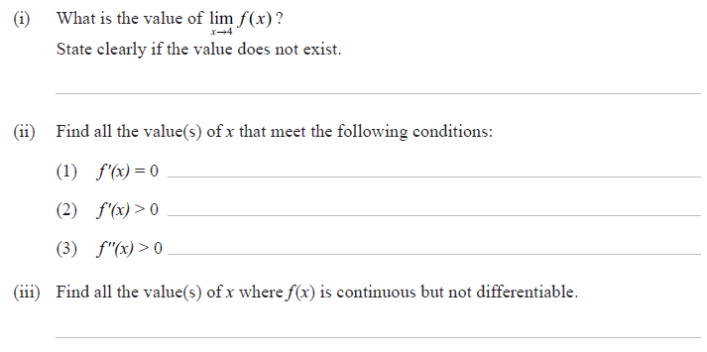

3

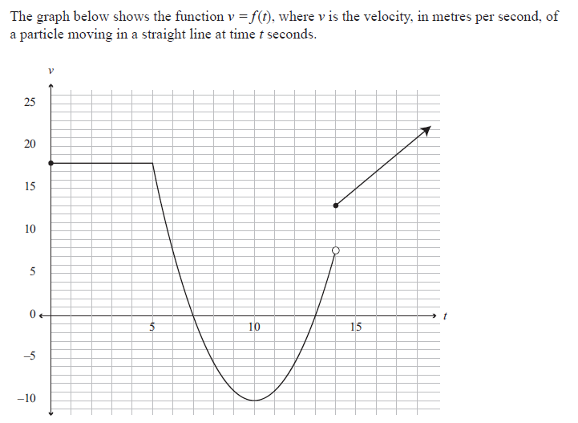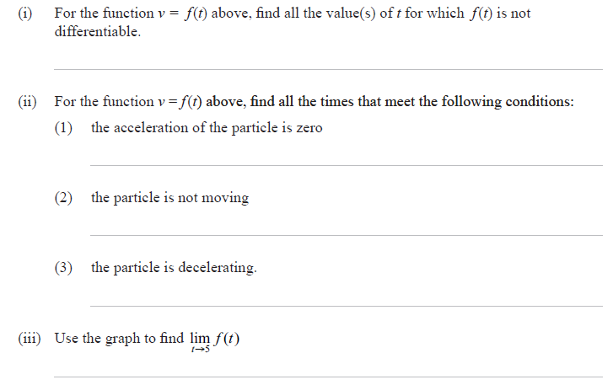



1. **Rates of change**

It is where one quantity changes with respect to the other. For example, if is the volume and is the height then is the rate of change of volume with respect to height.

**Example 1:** Find the rate at which the volume is changing with respect to the radius when the radius is 5cm for a given sphere.

**Example 2:** The altitude of a cone is twice its radius.

1. Find the volume in terms of altitude (h).
2. Find
3. Find h when is 20

**Example 3:** The concentration of a certain medication in the bloodstream hours after taking it is given by (the unit of is ppm, parts per million)

1. Calculate
2. Calculate
3. Interpret these results in context of the drug in the bloodstream.

**Answer**

After half an hour the amount of drug is 16ppm and increasing fast; after one hour the amount reaches its maximum of 20ppm; after two hours the amount is again 16ppm and decreasing slowly.



**Kinematics**

Kinematics is the study of motion of particles without reference to mass. Typically the particle moves on a straight line path.

Letter is used to represent distance or displacement from the origin (starting point).

Letter is used to represent height when a body travels vertically.

Where is velocity or speed and

is the acceleration.

Note is deceleration

Example: A particle starts at the origin and moves on a straight line. The distance to the origin after seconds is given by metres.

1. Find the formulas for its velocity and acceleration.
2. Find velocity and acceleration at t=1 and t=2 seconds.
3. i) Solve

ii) Describe, in terms of movement of the particle, what is happening at the time.



**4 Related Rates of Change**

Many rates of change problems involve 3 variables one of which is time. We solve these by applying ***chain rule:***

**Steps**

* Write down the rate of change that is wanted and the rate of change that is given.
* Write down the chain rule relating these two rates, there will be a missing part.
* Write down a formula which enables you to derive the missing part.
* Substitute all given values and evaluate.

***Note****: In some cases you can use implicit differentiation which is chain rule in different form.*

**Examples:**

1. The radius of an air bubble is increasing at a rate of 4mm per second. At what rate does the volume of the bubble increase when the radius is 7mm? (Assume the air bubble is a sphere).
2. The radius of the base of an inverted cone is 10cm and its altitude is 20cm. If water is poured into the cone at the rate of 100 find the rate at which the water is rising when it is 15cm deep.
3. A ladder of length 5m is standing on horizontal ground and leaning against a vertical wall. The foot of the ladder is pulled away from the wall at a constant speed of. At what speed is the top of the ladder moving down the wall at the instant when it is 4m above the ground?



[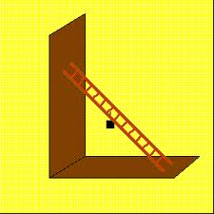](http://www.google.co.nz/imgres?imgurl=http://demoweb.physics.ucla.edu/sites/default/files/demomanual/mechanics/statics/lnnglddr.gif&imgrefurl=http://demoweb.physics.ucla.edu/node/434&h=288&w=288&sz=4&tbnid=KiGPoocPKMgLRM:&tbnh=89&tbnw=89&zoom=1&usg=__2SW_m466TlgQ_mYMSLmmB_1oTeY=&docid=HFvBMFO6PHCzoM&sa=X&ei=ihXaUfHxK6SPiAeYmIDAAw&ved=0CC4Q9QEwAQ&dur=1486)

1. A TV camera is located opposite the finishing post at a race-course. It is filming the leading horse in a race, which is running just inside the rail at a steady speed of 16m/s. The track is 15m wide. Calculate the rate of rotation of the camera in radians per second when the leading horse is 50m from the finishing line.
2. A light on a lamp-post in front of the school is above a horizontal ground. One wintery night after parent teacher interview Mr Basha who is tall, walks on the road away from a lamppost at a constant speed of. At what speed is the tip of his shadow moving (i.e rate at which his shadow is changing) when he is from the lamppost.



Worksheet

1

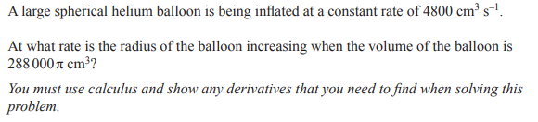

2

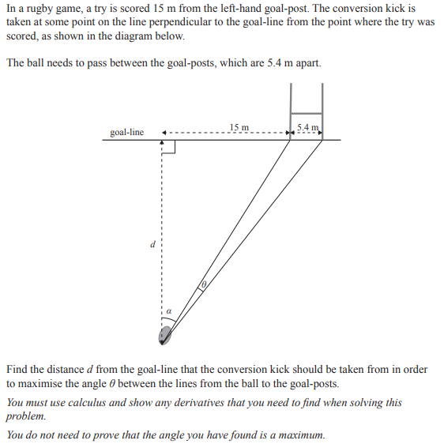

3

3

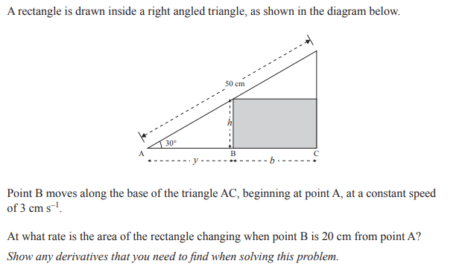

4

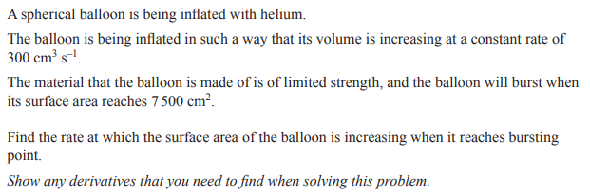

5

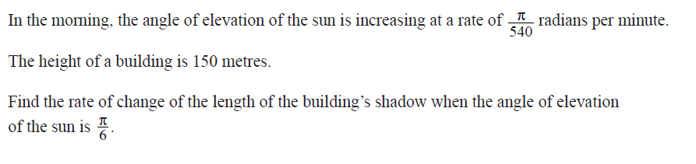

Note

The related rates of change problem can have more than 3 variables:

Example 1: A large spherical balloon is losing gas at a rate of per minute. At what rate is the surface area decreasing when the radius is

Example 2: A large cube of mouth-watering delicious French vanilla ice cream is melting, its surface area decreases at a rate of per hour. At what rate is the volume of the cube decreasing when its sides are

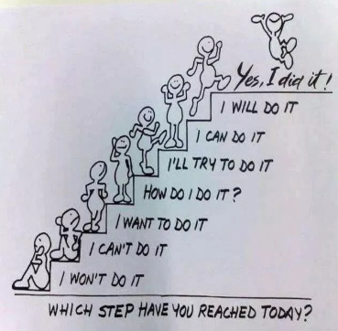

1. **Optimisations**

Calculus can be used to solve certain problems in which some Optimum (Maximum or Minimum) value is required.

**Steps:**

* Using the information given, write down the required Quantity equation in **one** variable.
* Differentiate the Quantity equation.
* Equate the derivative to zero (either for maximum or minimum) and solve.
* Check your answers for maximum or minimum by second derivative test or first derivative test (i.e sign of gradient about the turning point).
* Substitute all given values and evaluate

Examples:

1. A piece of wire 120cm long is bent into shape of a rectangle so that the wire overlaps along one side as in the diagram.

What is the maximum area that the rectangle can have?

1. The volume of a solid cylinder is 27cm3. What is the radius of the base if the total surface area is to be a minimum?
2. Find the volume of the largest cylinder which fits inside a sphere of radius 1m. (Hint: let the radius of the cylinder be, m).

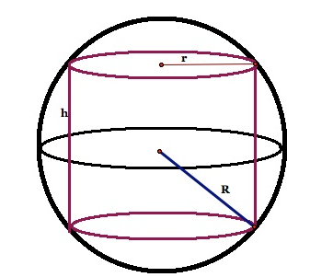

1. A piece of wire long is cut into two pieces. One piece is a square and the other an equilateral triangle. What is the length of each piece if the sum of the areas of the two shapes is minimum?
2. Cylindrical containers for dried fruits is made from cardboard with plastic top and bottom. Per square centimetre, plastic costs three times as much as cardboard. The volume of the container is 2000cm3. Find the dimensions that minimise the cost.

